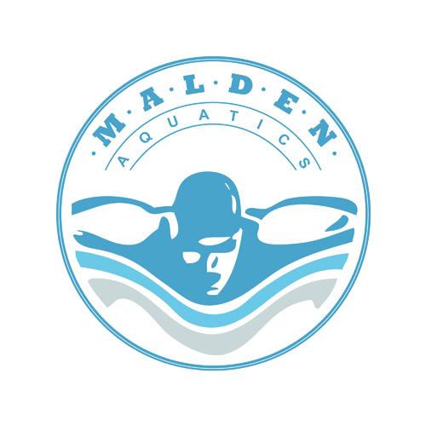

Pre-requisite Swim:
http://www.maldenaquatics.com/ - !lifeguarding/ci85
http://www.maldenaquatics.com/water-safety-instructor

Click on the link above to view a list of the pre-requisite skills that must be completed on the first day of class. It is important that you make sure you are comfortable with the required skills prior to coming to class. All skills must be completed in order to take this course.
What items should I bring to class?
- Bathing suit
- Towel
- Sweatshirt
- Pocket Mask (only if taking a review course)
- Pencil/Pen
- Snacks/Lunch (There is a refrigerator available on the facility).
- Proof of age (If you do not have a drivers license please have a copy of your birth certificate or passport available).
- Copy of online course work completion letter. (This will need to be printed after you have completed your online work prior to the first day of class. Not required for recertification courses).

Facility Address: Deerkill Day Camp - 54 Wilder Road, Suffern, NY 10901
We look forward to seeing on the first day of class! If you have any questions or concerns please feel free to email or call.

Thank you,
Mathew Malden - Owner/Director
(845) 641-3769 / info@maldenaquatics.com

